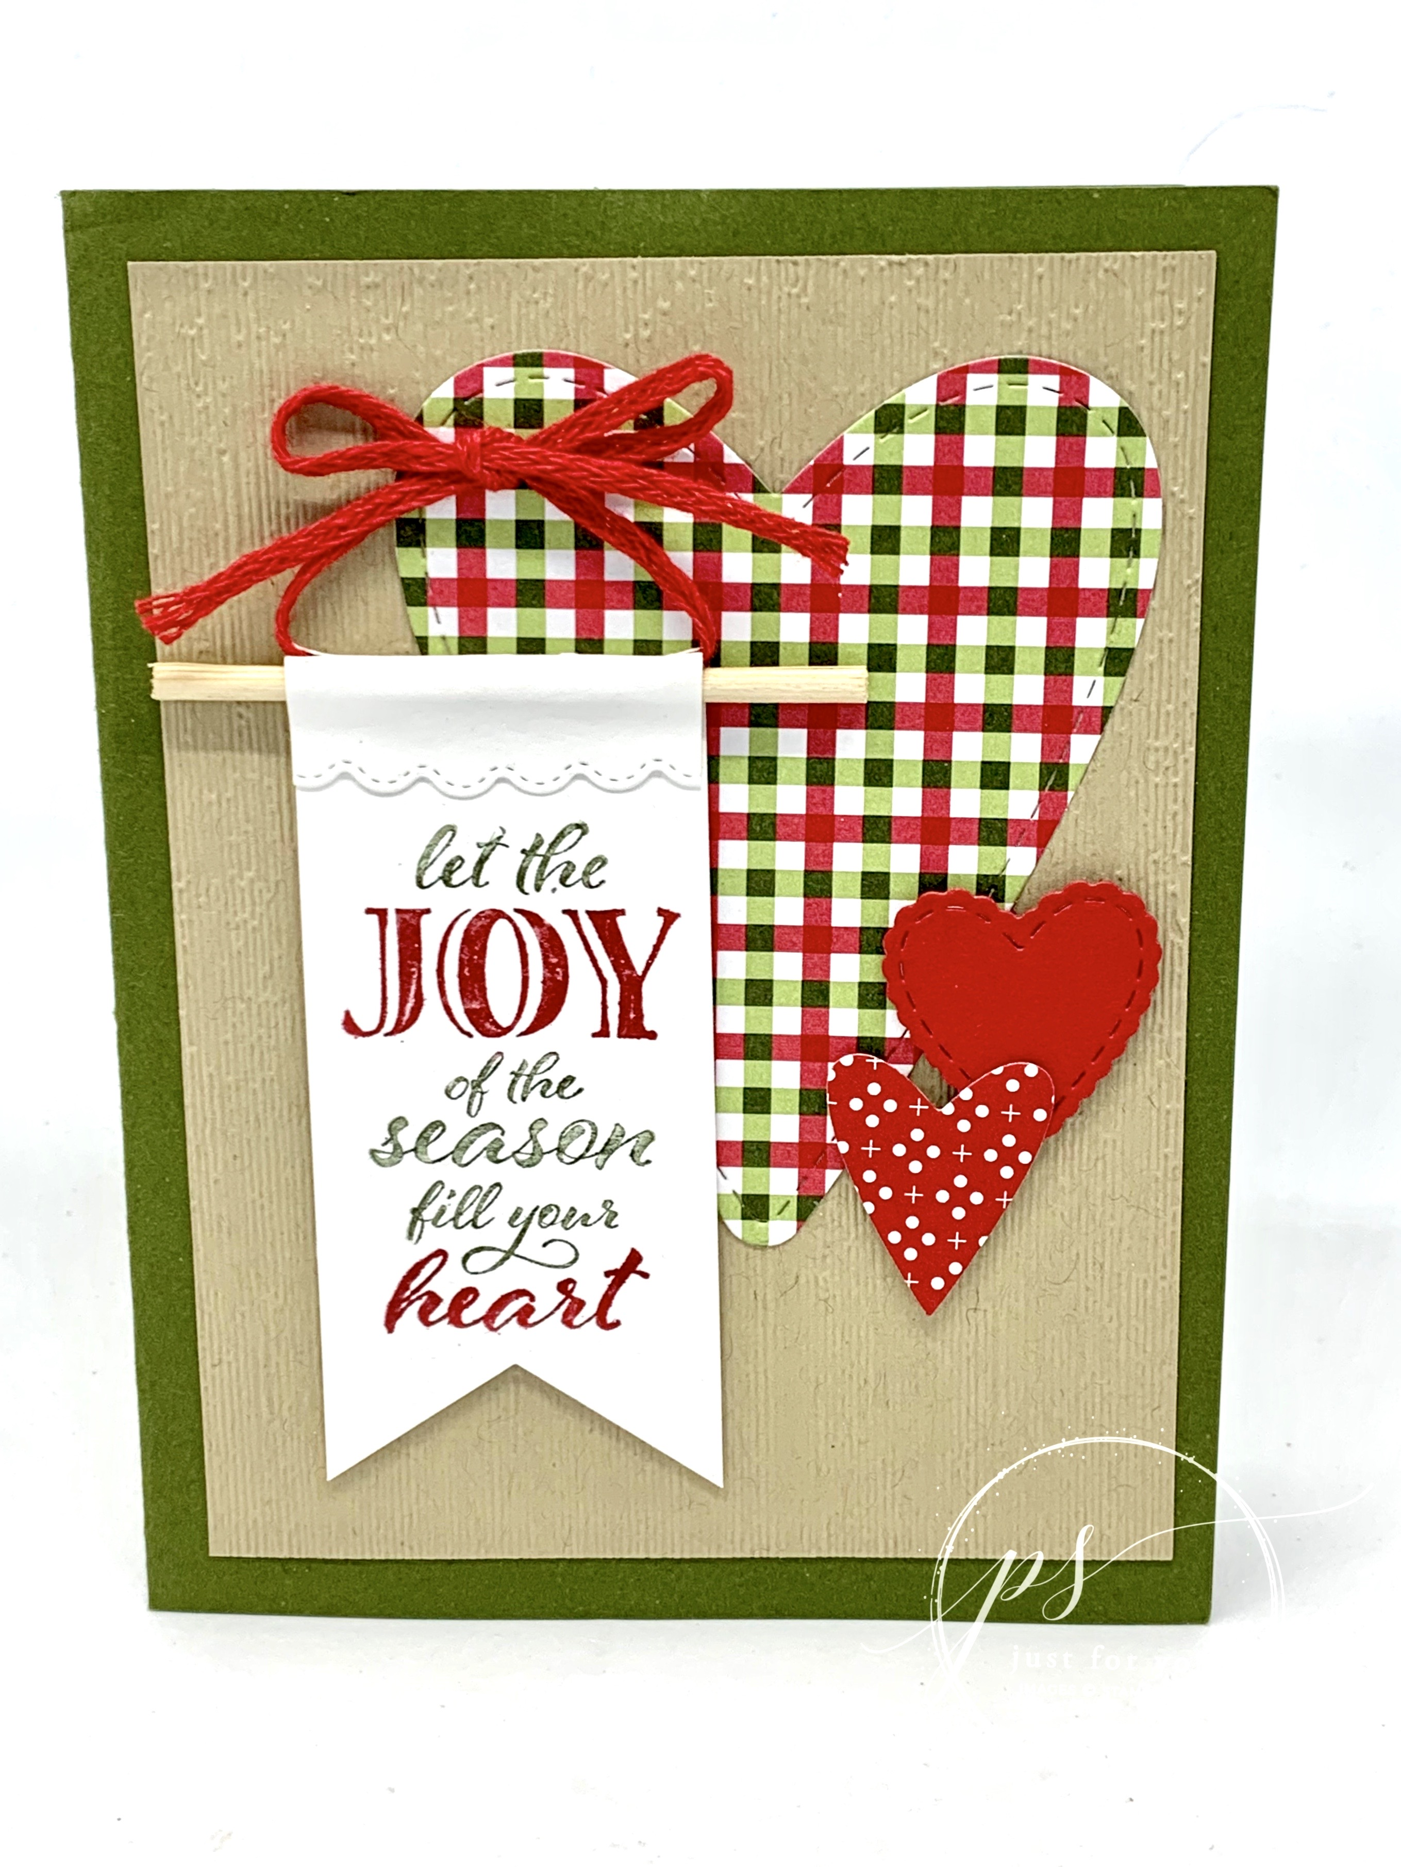
Wrapped in Christmas Banner Card
All images © 1990-2020 Stampin’ Up!®

Supplies:
- Stamp Sets – Wrapped in Christmas (153481)
- Card Stock – Crumb Cake (333333); Mossy Meadow (133676); Real Red (102482); Whisper White (100730)
- Ink – Mossy Meadow Stampin’ Write Marker- (Neutrals 147158); Real Red Stampin’ Write Marker (Regals 147155)
- Misc. – Heartwarming Hugs Designer Series Paper (DSP) (153492); Warm Wraps Dies (153521); Stitched Be Mine dies (151814); Subtle 3D Embossing Folder (151775); Real Red Braided Linen Trim (153546); Stampin’ Cut & Emboss (159653); Banner Triple Punch (138292); Dimensionals (104430); Bone Folder (102300); Glue Dots (103683); Wooden skewer

Measurements:
- Mossy Meadow card stock: 8 1/2” x 5 1/2”
- Crumb Cake card stock: Two of 3 3/4” x 5”
- Whisper White card stock: 1 1/2” x 4 1/4”
- Real Red card stock: 2” x 2”
- DSP: 3” x 4” plus extra scrap for small heart
- Real Red trim: 12”
- Wooden Skewer: 2 1/2”

Instructions:
- Emboss one of the crumb cake card stock pieces and layer on front of Mossy Meadow card and the other piece goes inside the card to write on.
- Cut 1 large and 2 small hearts from Designer Series Paper and Real Red card stock as shown. Adhere the largest to the front of the card and the smaller ones attach with dimensionals.
- Cut one end of the Whisper White strip using the scallop edge from the Warm Wraps Dies and punch the opposite end using the Banner Triple punch. Use the Red and Mossy Meadow markers to color directly on the stamp for the greeting, then stamp it toward the bottom (banner) end of the white strip.
- Once the ink on the white card stock is dry, use bone folder to curl the scallop top toward the front. Lay the red trim inside the curl along with the skewer and adhere top scallop to front of the banner with glue dots. Tie a loose bow with the ends of the red trim.
- Attach the banner to card front with dimensional and adhere the bow with a glue dot.

