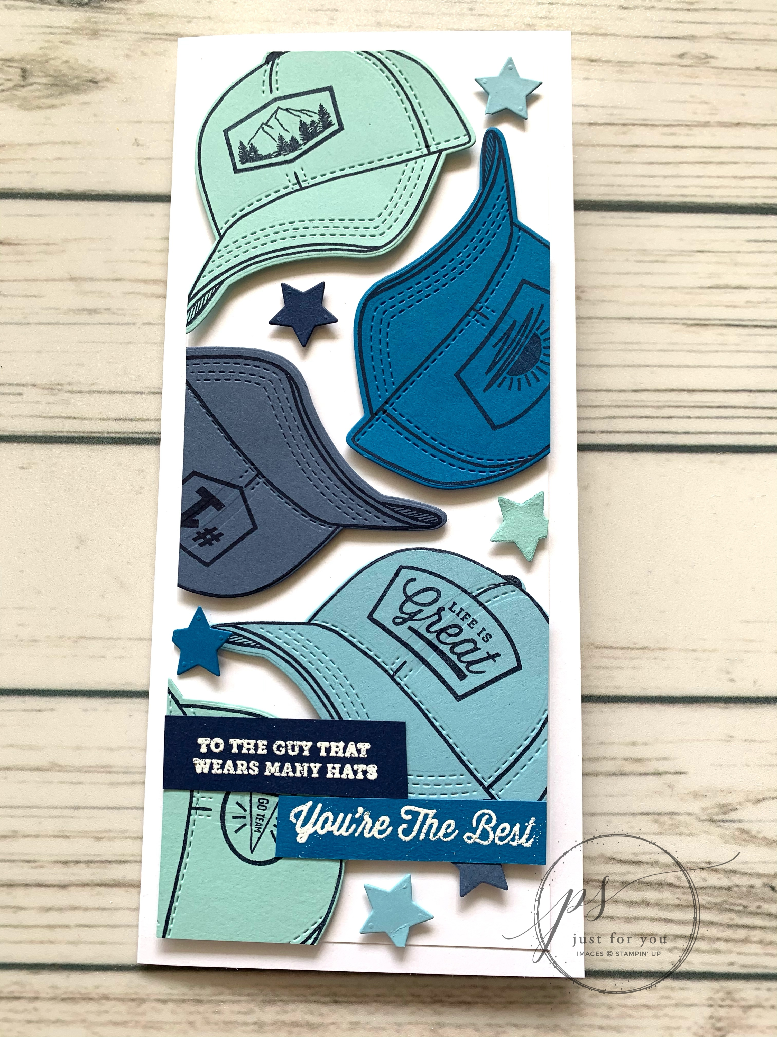
Hats Off Slimline Card
All images © 1990-2021 Stampin’ Up!®

Supplies:
- Stamp Sets – Hats Off Bundle (158361)
- Card Stock – Basic White Thick(159229); Basic White (159276); Pool Party (122924); Pacific Point (111350); Misty Moonlight (153081); Balmy Blue (146982); Night of Navy (100867)
- Stamp Pads – Night of Navy (147110); Whisper White (147277)
- Misc. – Basics Embossing Powders (155554); Heat Tool (129053); Mini Stampin’ Dimensionals (144108); Stampin’ Seal (152813); Stampin’ Cut & Emboss (149653); OPTIONAL- Paper Trimmer (152392)

Measurements:
- Basic White Thick: 9” x 8” scored at 4” for card base
- Basic White: 3-1/2” x 8-1/2”
- Pacific Point, Balmy Blue, Misty Moonlight and Pool Party: 4” x 3” (plus one extra Pool Party)
- Night of Navy: 5/8” x 4”
- Pacific Point: 1/2” x 4”

Instructions:
- Stamp a hat image on each of the larger blue rectangles and a patch on each hat with Night of Navy ink. Cut each one out with the coordinating dies on the Stampin’ Cut & Emboss machine, along with a star.
- Adhere the hats to the front of the 3-1/2” x 8-1/2” white card stock with SMALL amount of Stampin’ Seal, letting some of the hats hang over the edge. Use paper trimmer or scissors to cut off any pieces hanging over the edge of the white card stock.
- Remove each piece and add dimensional to raise the image, then place it back where it was. Add stars on dimensionals between hats.
- Adhere to the panel to the front of thick white card base
- Heat emboss sentiments on the small blue strips, cut down to desired size and attach to front of card.

